LIST OF FIGURES
Figure 1. Comparison of the profile of the participants from the traditional university and the distance university.
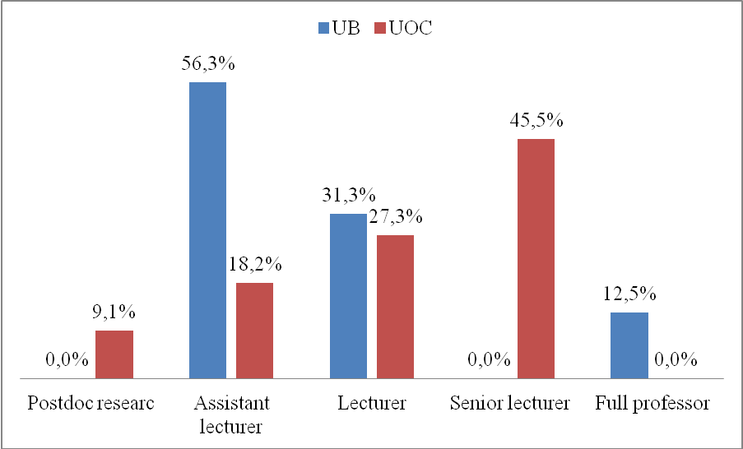

Figure 2. Comparison of participation by teachers from a traditional university and a virtual university in a massive open online course.
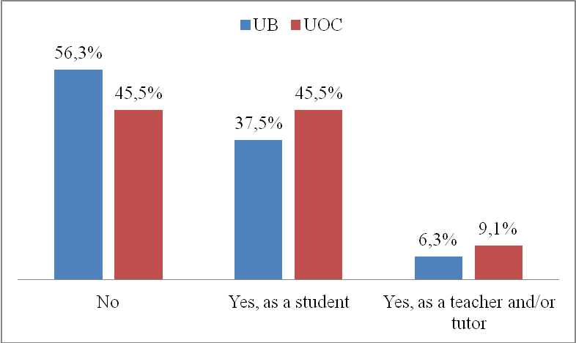

Figure 3 and 4. Comparison of the "tag clouds" for the definition of massive open online courses used by teachers from a traditional university (on the left) and a virtual university (on the right).

Figure 5. Benefits of the new massive open online courses. Teachers’ perceptions comparison (UOC-UB).
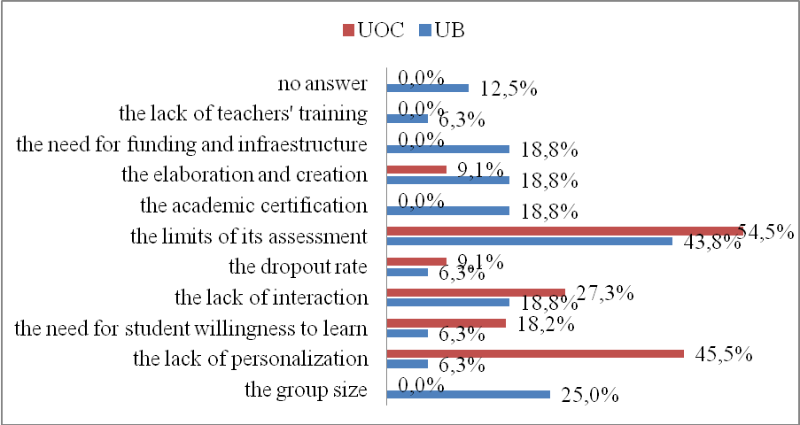

Figure 6. Pedagogical limits of MOOCs. Teachers’ perceptions comparison (UOC_UB).
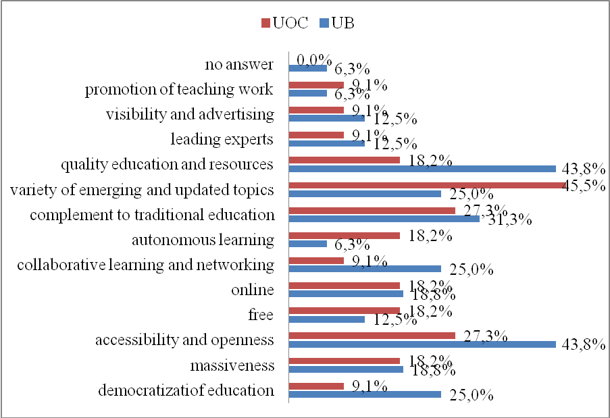

Figure 7 and 8. Comparison of the "tag clouds" for the definition of teachers’ or tutors’ functions in a MOOC used by teachers from a traditional university and a virtual university.

