CCK11 cluster descriptions. Supplement to the analysis of CCK11 twitter interaction patterns.

This document supplements the analysis of course interactions taken place on twitter during CCK11. The document presents profiles of the sub-communities of learners who participated in the course.

Having applied modularity algorithm over the large connected component of the course network, we identified 19 communities. This supplement presents the demographic information for the social nodes in the various sub-communities, which helps understand the profile of each course community. The summary table in the beginning of this document lays out major descriptive information for the biggest 8 sub-networks. The remaining 11 sub-networks each make up less than 1% of the entire network, and therefore, are not presented in the comparative summary. However, all sub-networks are described in greater detail, following the comparative summary.

Table A1. CROSS-CLUSTER SUMMARY
Cluster Number | 1 | 2 | 3 | 4 | 5 | 6 | 7 | 8
Suggested Profile | Education Practitioners | Researchers | Digital Pedagogy | Technology for Teachers | English Teachers | OER | Smoky_stu | Complexity theory
Feature Nodes | @cck11 | @downes  @gsiemens  @daisygrisolia  @juandoming | @ianchia  @courosa | @web20education  @larisa113 | @profesortbaker  @profesorbaker  @shellterrell | @saadat_m  @neil  @rdlln | @smoky_stu | @gardenfelder  @essentialcm
Prominent Hashtags |  | #elearning  #connectivism  #eadsunday | #musedchat | #edtech20 | #esl  #eltchat  #edchat  #ukedchat | #plenk12  #oer  #mobimooc  #digital #natives | #edtech  #yam | #complexity  #sensemaking  #cynefin  #kmiou
Part of the whole | 26,12% | 24,49% | 17,96% | 11,84% | 9,2% | 3,1% | 1,88% | 1,06%
Social nodes, # | 233 | 214 | 28 | 44 | 81 | 14 | 9 | 9
Technical nodes, # | 82 | 84 | 3 | 110 | 30 | 23 | 11 | 5
Female participants, % | 39,06% | 32,24% | 50,00% | 25,00% | 44,44% | 50,00% | 11,11% | 11,11%
Male participants, % | 41,20% | 43,93% | 42,86% | 38,64% | 37,04% | 85,71% | 55,56% | 44,44%
Organizations, % | 13,30% | 13,55% | 3,57% | 25,00% | 17,28% | 14,29% | 33,33% | 22,22%
Research, % | 21,03% | 16,82% | 10,71% | 6,82% | 0,00% | 14,29% | 0,00% | 22,22%
Practice, % | 49,79% | 43,46% | 60,71% | 50,00% | 79,01% | 78,57% | 44,44% | 22,22%
Mixed (both), % | 6,44% | 14,49% | 21,43% | 6,82% | 6,17% | 0,00% | 0,00% | 44,44%
Business, % | 10,30% | 4,21% | 3,57% | 11,36% | 4,94% | 0,00% | 22,22% | 22,22%
Community, % | 0,86% | 0,00% | 0,00% | 0,00% | 1,23% | 0,00% |  | 0,00%
Secondary education, % | 0,86% | 6,07% | 35,71% | 18,18% | 16,05% | 14,29% | 22,22% | 0,00%
Entrepreneurship, % | 8,15% | 10,75% | 28,57% | 2,27% | 1,23% | 14,29% | 0,00% | 33,33%
Health, % | 2,58% | 0,00% | 0,00% | 0,00% | 12,35% | 0,00% | 0,00% | 0,00%
Library, % | 0,43% | 1,87% | 3,57% | 0,00% | 1,23% | 0,00% | 0,00% | 0,00%
Higher Education, % | 28,76% | 40,19% | 17,86% | 6,82% | 12,35% | 42,86% | 0,00% | 0,00%
Languages, % | 2,58% | 1,87% | 3,57% | 6,82% | 32,10% | 14,29% | 0,00% | 0,00%
Government, % | 0,00% | 0,93% | 0,00% | 2,27% | 0,00% | 7,14% | 0,00% | 0,00%
Elementary and primary education, % | 0,00% | 0,47% | 0,00% | 9,09% | 1,23% | 14,29% | 0,00% | 0,00%
Other, % | 2,58% | 0,47% | 0,00% | 9,09% | 2,47% | 0,00% | 0,00% | 0,00%
Various, % | 3,86% | 2,80% | 0,00% | 0,00% | 3,70% | 0,00% | 0,00% | 22,22%
Unknown, % | 10,73% | 9,81% | 10,71% | 4,55% | 12,35% | 35,71% | 22,22% | 0,00%
North America, % | 35,19% | 33,18% | 57,14% | 29,55% | 35,80% | 14,29% | 22,22% | 33,33%
South America, % | 6,87% | 14,02% | 3,57% | 0,00% | 9,88% | 0,00% | 0,00% | 0,00%
Europe, % | 27,90% | 28,04% | 14,29% | 31,82% | 30,86% | 71,43% | 0,00% | 33,33%
Australia and NZ, % | 9,01% | 4,21% | 3,57% | 6,82% | 4,94% | 14,29% | 22,22% | 0,00%
Asia, % | 3,43% | 1,87% | 3,57% | 0,00% | 0,00% | 21,43% | 0,00% | 0,00%
Africa, % | 0,00% | 0,47% | 0,00% | 0,00% | 1,23% | 0,00% | 0,00% | 0,00%
Unknown, % | 9,44% | 13,08% | 7,14% | 13,64% | 8,64% | 28,57% | 22,22% | per

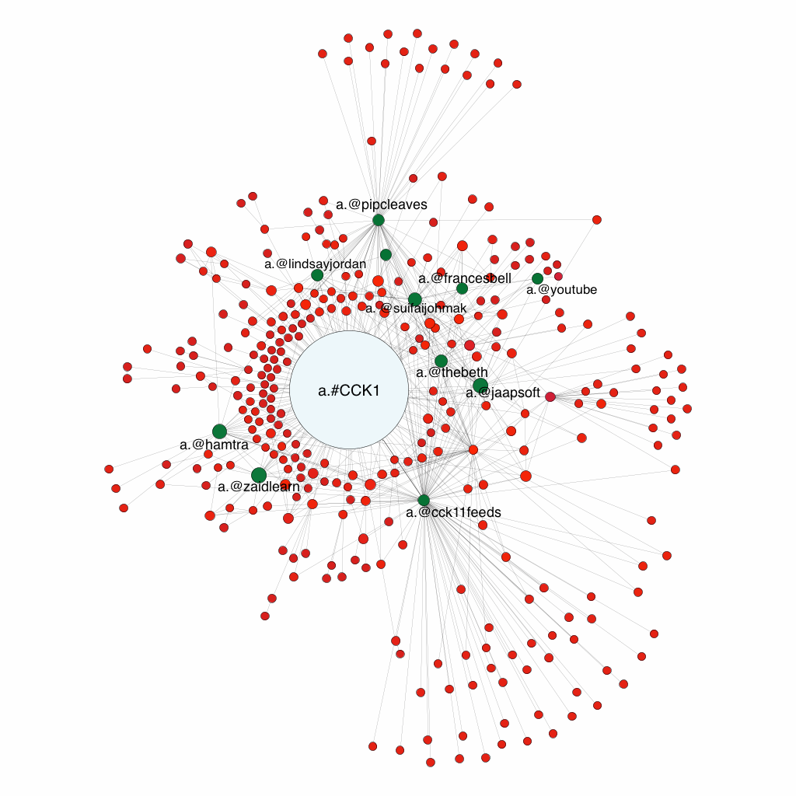

Sub-network 1 - CCK11- Education Practitioners

Sub-network # | % of the entire Network | # of nodes | # of social nodes | #of technical nodes | # of edges
1 | 26.12% | 320 | 233 | 82 | 629

Who makes up this sub-network?

- The gender distribution is equal.
(F=91; M=96, Organizations=31, Unknown – 18.)

- Predominantly practice-oriented professionals
(Research=49; Practice=116; Mixed (both)=15)

- Participants predominantly located in North America and Europe
(North America =82; South America =16, Europe=65, Australia and NZ =21, Asia =8, Unknown=22)

- Most frequent occupation is within higher education. Second largest group is either working for a commercial company or self-employed.
(Business=24; Community=2, Secondary education=2, Entrepreneurship=19; Health=6, Library=1, Higher education=67, Languages=6, Other=6, Various=9, Unknown=25)

- Within higher education researchers, the majority comes from Europe and North America.
(HE Europe =17; HE Australia and NZ=1; HE North America=7; HE South America=1; HE Asia =1). HE research =27, HE practice 28; HE Mixed – 10)

Although this group is predominantly practitioners, which in many cases implies professional development and adult learning at workplaces, the sub-groups characterized as higher education researchers who work in both research and practice include all the social nodes with high authority and in-degree weights, i.e. @gordon_l, @francesbell, @daily, @thebeth, @ailsa)

Sub-network 2 – CCK11 - Researchers

Sub-network # | % of the entire Network | # of nodes | # of social nodes | #of technical nodes | # of edges
2 | 24.49% | 300 | 214 | 84 | 466

Who makes up this sub-network?

- The gender distribution is not as equal as in the first cluster, and more male dominated.
(F=69; M=94, Organizations=29, Unknown –22.)

- Interpretation of this data directly as a more practice-oriented cluster should be done
with caution. Mixed category refers to researchers who practice enough to make both field equally important in desciribing them, which roughly speaking, lifts the number of those in research field to 61. (Research=36; Practice=93; Mixed (both)=31, Unknown=10)

- Participants predominantly located in North America and Europe. South American
group in this cluster almost doubled from the previous ones, which is due to a small Brazilian sub-network by @daisygrisolia and a number of tweets by @juandoming reaching to Spanish speaking audiences. (North America =71; South America =30, Europe=60, Australia and NZ =9, Asia =4, Africa=1, Unknown=28)

- Most frequent occupation is within Higher Education, but the commercial sector is
comparatively small. (Business=9; Community=0, Secondary education=13, Entrepreneurship=23; Health=0, Library=4, Higher education=86, Languages=4, Other=1, Various=6, Government=2; Elementary and primary education=1; Unknown=21)

Within higher education professionals, there are mostly researchers. Mixed group
basically means researchers who also are connected to practice often, for example regularly teach or consult in settings other than formal education. Within higher education group, the majority comes from Europe and North America.
(HE research=32. HE practice=28. Mixed=24; HE Europe =35; HE Australia and NZ=4; HE North America=30; HE South America=13; HE Asia =1; Unknown=1)

Without inputting the demographics within the network, we can say that the left sub
network is Brazilian, united by @daisygrisolia and #eadsunday (“distance education” in Portuguese) and #innovareduca – innovation education network. The two sub-networks around two original course facilitators.

Because this cluster hosts most of the guests and reputed researchers in the field of online education, and the highest number of researchers, we label it as “Researchers”, but we acknowledge that the demographics in this cluster is rather diverse, and this conclusion is more operational, than reflecting the full picture.

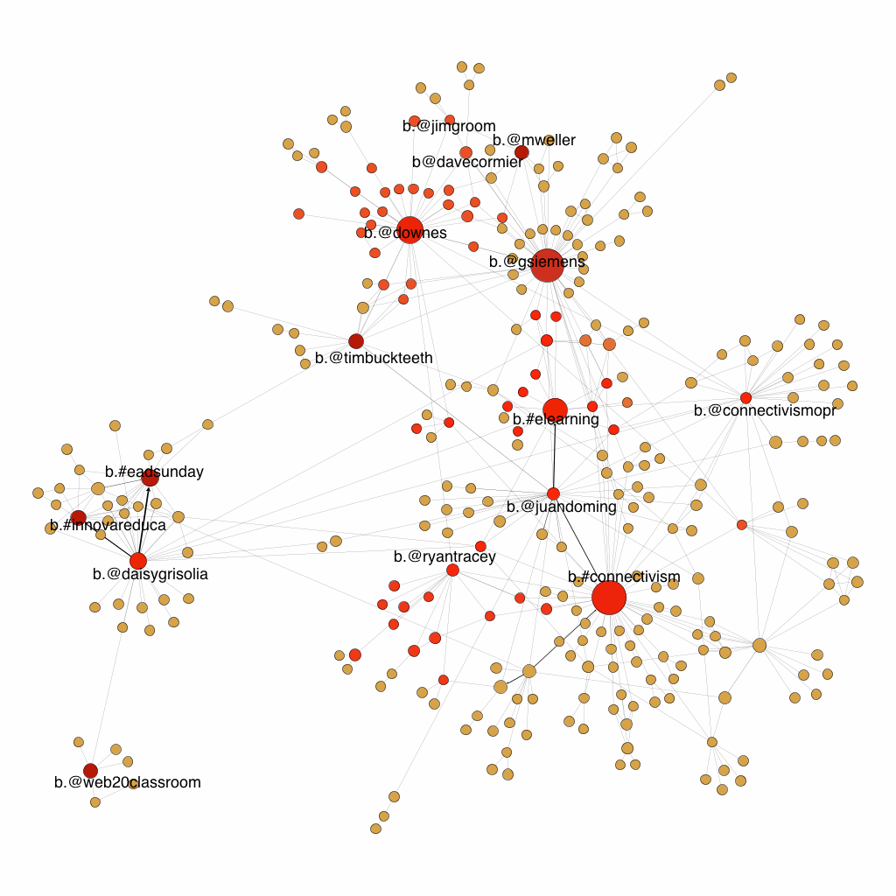

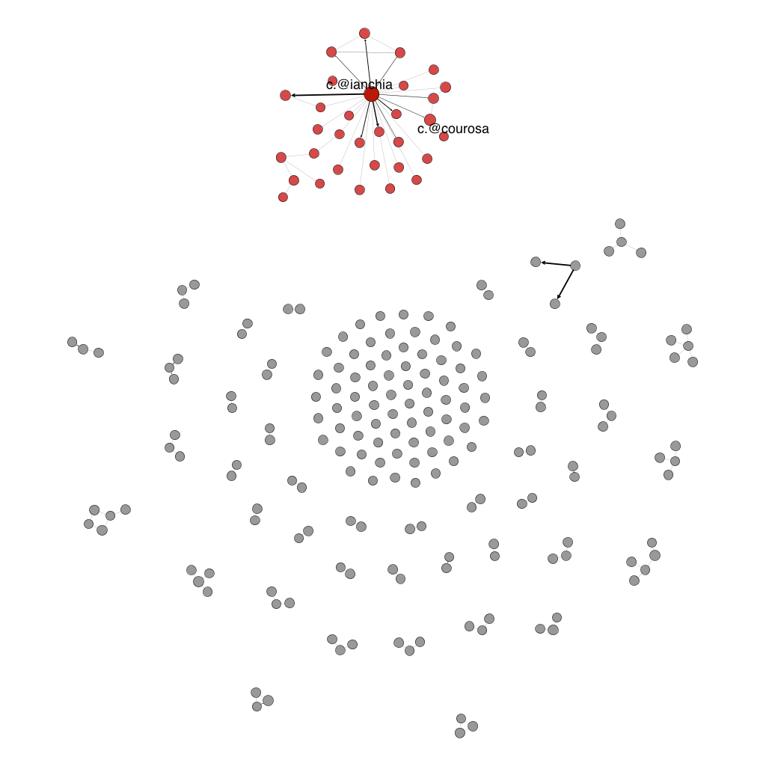

Sub-network 3 – CCK11 – Kids, Games, Digital Pedagogy

Sub-network # | % of the entire network | # of nodes | # of social nodes | #of technical nodes | # of edges
3 | 17.96% | 31 | 28 | 3 | 119

Who makes up this sub-network?

- The gender distribution is balanced.
(F=14; M=12, Organizations=1, Unknown=2.)

- Predominantly practice-oriented professionals.
(Research=3; Practice=17; Mixed (both)=6, Unknown=1)

- Participants predominantly located in North America.
(North America=16; South America=1, Europe=4, Australia and NZ =1, Asia =1, Africa=0, Unknown=2)

- Most frequent occupation is within secondary education and entrepreneurship.
(Business=1; Community=, Secondary education=9, Entrepreneurship=8; Health=, Library=1, Higher education=5, Languages=1, Other=0, Various=1, Government=0; Elementary and primary education=; Unknown=3)

The most prominent node @ianchia is an entrepreneur making online games for children. Close examination of the cluster shows the following trends: five people have background in arts or music and/or engage in creative writing. One of a few hashtags is #musedchat, which refers to music education. Seven people from this cluster in their personal profiles refer to kids, games and play, either researching or making them. One of the social nodes, @courosa is the reputed researcher and practitioner with focus on digital pedagogy, and prior to the in-depth analysis of what these people may have discussed, we can hypothesize that children, digital pedagogy and creative play may have been a common interest.

Sub-network 4 – CCK11 – Technology for Teaching

Sub-network # | % of the entire network | # of nodes | # of social nodes | #of technical nodes | # of edges
4 | 11.84% | 145 | 44 | 110 | 249

Who makes up this sub-network?
- The gender distribution is balanced. Of particular attention is the relatively
high number of organizations twitter accounts that are a part of the cluster.
(F=11; M=17, Organizations=11, Unknown=6.)

- Predominantly practice-oriented professionals,
(Research=3; Practice=22; Mixed (both)=3, Unknown=0)

- Participants predominantly located in North America.
(North America=13; South America=0, Europe=14, Australia and NZ =3, Asia =0, Africa=0, Unknown=6)

- Most frequent occupation is within secondary education and elementary and primary education.
(Business=5; Community=0, Secondary education=8, Entrepreneurship=1; Health=0, Library=0, Higher education=3, Languages=3, Other=4, Various=0, Government=1; Elementary and primary education=4; Unknown=2)

Two leading nodes are @larisa1113 and @web20education are two European secondary school teachers, followed by a relatively high number of secondary education and primary and elementary education professionals. Judging from the content of a very high number of hashtags (over 100) we can say that this sub-network used content about the use of technological tools in a classroom.

Technical nodes characterizing this sub-network are: #lak11, #lrnchat, #edtech20, #scoopit, #elt, #efl. Due to the visual structure of the network, high number of hashtags and low number of interactions in between participants leads to believe that a lot of content production in this network was motivated by self-promotion, which still does not exclude some shared interest among practitioners of secondary, elementary and primary education related to the use of tools in their classrooms.

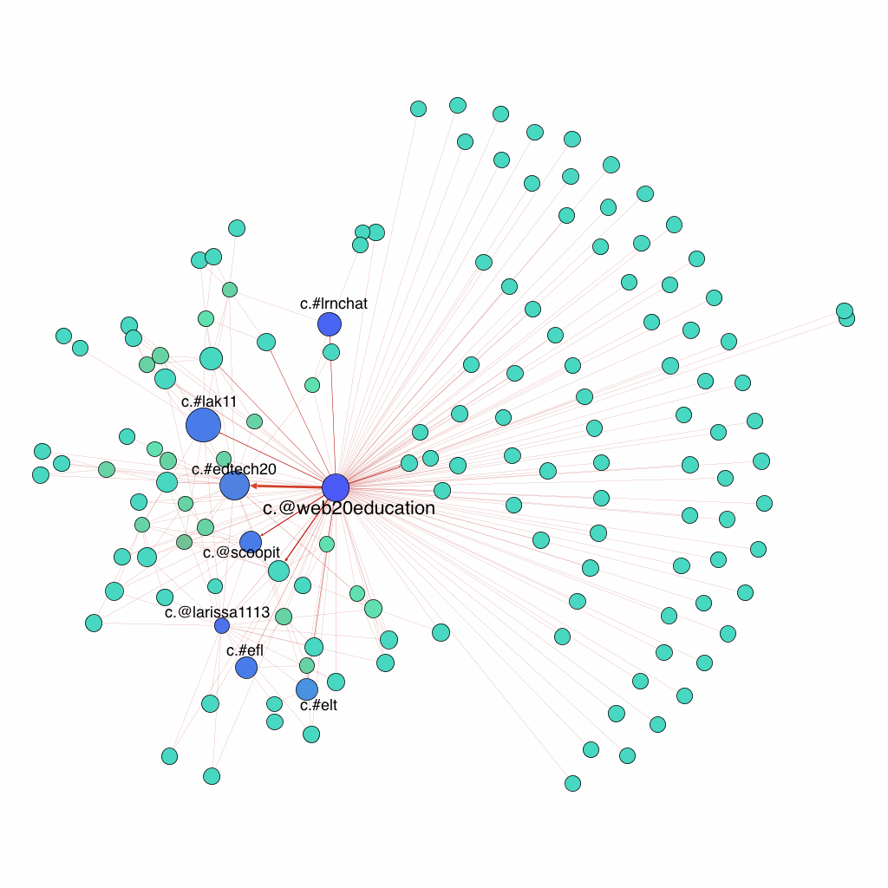

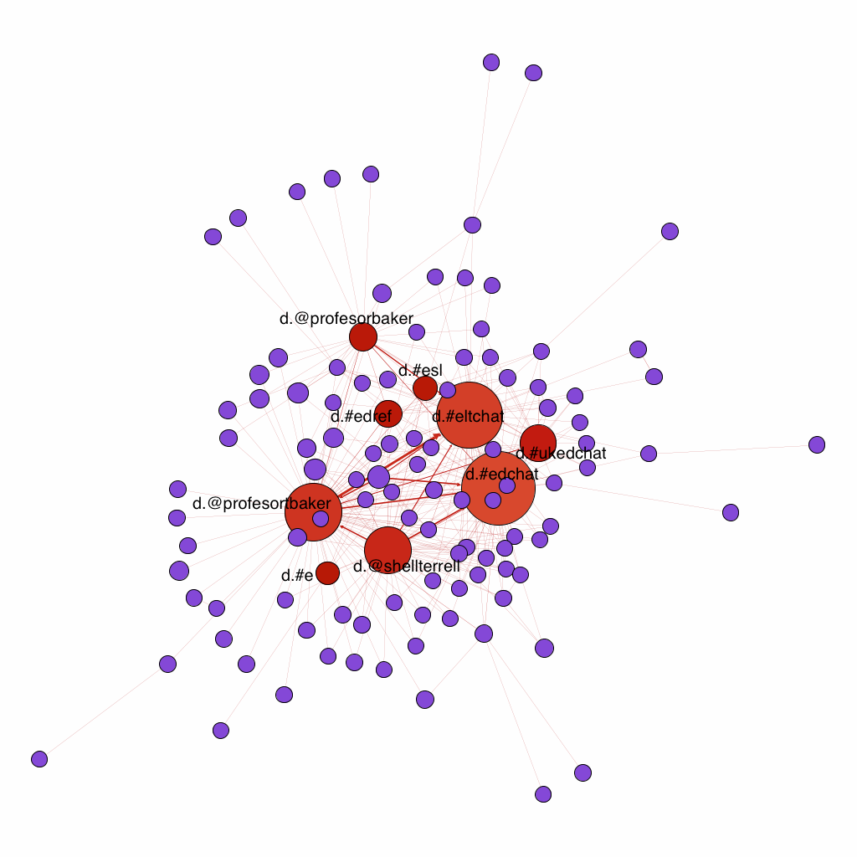

Sub-network 5 – CCK11 – English Teachers

Sub-network # | % of the entire network | # of nodes | # of social nodes | #of technical nodes | # of edges
5 | 9.2% | 113 | 81 | 30 | 344

Who makes up this sub-network?

- The gender distribution is balanced.
(F=36; M=30, Organizations=14, Unknown=2.)

- Predominantly practice-oriented professionals, with as few as 5 professionals related to some research activity
(Research=0; Practice=64; Mixed (both)=5, Unknown=0)

- Participants predominantly located in North America and Europe
(North America=29; South America=8, Europe=25, Australia and NZ = 4, Asia =0, Africa=1, Unknown=7)

- Most frequent occupation is within languages, specifically English teaching and secondary education. In this cluster we coded participants with English teaching background as languages, regardless whether they work at universities or schools- since often teaching English at tertiary level does not imply socialization into academia. The only exception was English for Academic Purposes professionals with academic positions. Moreover, entrepreneurs teaching English online or having English teaching businesses were also coded as Languages to distinguish them as a large and distinct group.
(Business=4; Community=1, Secondary education=13, Entrepreneurship=1; Health=10, Library=1, Higher education=10, Languages=26, Other=2, Various=3, Government=0; Elementary and primary education=1; Unknown=10)

Among social nodes are @shellterrell and @profesorbaker, @blog4edu.
Both @professortbaker and @shellterrel are ELT professionals, from Chile and the US respectively. Technical nodes characterizing this sub-network are: #eltchat, #edchat, #ukedchat. Overall, although the fact that @profesortbaker and @profesorbaker are the same person points towards some degree of self-promotion, due to the correlations between the trending hashtags and the backgrounds of the participants, as well as due to relatively low number or hashtags as compared to the social nodes, we tend to view this sub-network as English Language Teaching and Secondary School Teaching Community.

Sub-network 6 – CCK11 – OER
Sub-network # | % of the entire network | # of nodes | # of social nodes | #of technical nodes | # of edges
6 | 3.1% | 38 | 23 | 14 | 47

Who makes up this sub-network?

The gender distribution is slightly more male-dominated. Predominantly practice-oriented professionals. Participants predominantly located in Europe. Most frequent occupation is within higher education

- Three social nodes shaping the sub-network are @saadat_m; @rdliin, @neil.

- This sub-network captures three distributed conversations: one in the left top corner around Neil Selwyn @neil about #digital #natives; another one in the centre around a PhD student in open learning with such hashtags as #plek12, #oer, #opened, @mobimooc; and finally a smaller sub-network in the lower right corner by a participant who runs an online community for writers with hashtags such as #digital #storytelling.

It is difficult to identify the common strand, thus we use OER as operational label, based on the number of hashtags related to it, and learners around it (central sub-network on the image).

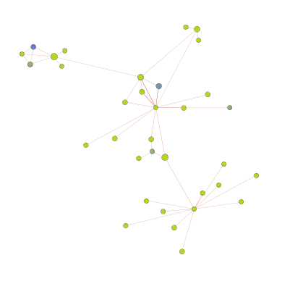

.

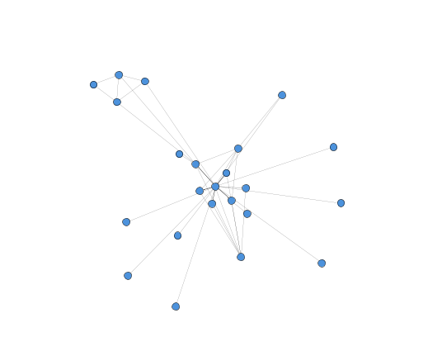

Sub-network 7 – CCK11 – @smoky_stu
Sub-network # | % of the entire network | # of nodes | # of social nodes | #of technical nodes | # of edges
7 | 1.88% | 23 | 9 | 11 | 37

Who makes up this sub-network?
- The cluster is male-dominated; practice-oriented professionals, located in North America and Australia.

- Technical nodes characterizing this sub-network are #edtech, #yam, #technology, #education.

- It is difficult to draw any distinct conclusions about the nature of the cluster based on the current data available.

Sub-network 8 – CCK11 – Complexity and Meaning Making
Sub-network # | % of the entire network | # of nodes | # of social nodes | #of technical nodes | # of edges
7 | 1.06% | 13 | 9 | 5 | 14

Who makes up this sub-network?
- The group is male-dominated, predominantly practice-oriented professionals, located in North America and Europe.

The central nodes are @gardenfelder and @essentialcm. It also hosts one learning analytics researcher. Technical nodes characterizing this sub-network are #complexity, #sensemaking, #cynefin, #kmiou, #social learning. Participants demographics contribute little to our understanding of the cluster profile.

This sub-network shows some shared interest in complexity theory – as associations between the various hashtags.

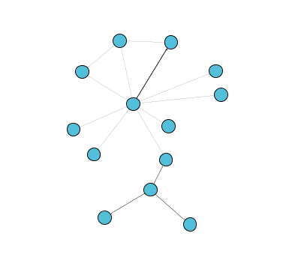

Sub-network comprises 0.09% of the entire network. It has 11 nodes (1 social and 10 technical), and 10 edges. The central nodes is @newfacmajority. Technical nodes characterizing this sub-network are #evomlit and others.  This is a self-promotion sub-network, by a node, which is an American organization that deals with professional development of academic staff, and was positioned as HigherEd Practice. | 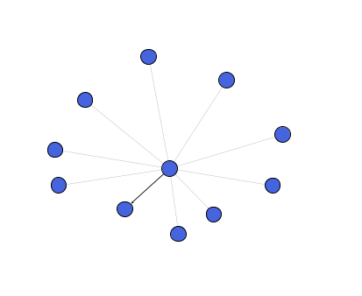 | Sub-network comprises 0.33% of the entire network. It has 4 nodes (1 social and 3 technical), and 3 edges. The central nodes is @sayazyi. Self-promotion sub-network: a new twitter for one of the active users, @vanessavaile, and her three hashtags. | 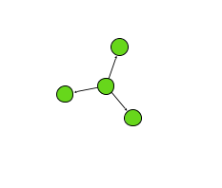
Sub-network comprises 0.073% of the entire network. It has 9 nodes (7 social and 2 technical), and 14 edges. The central nodes is #phdchat.All 7 social nodes in this sub-network were undertaking PhD studies in EdTech or related area at the time of the course. | 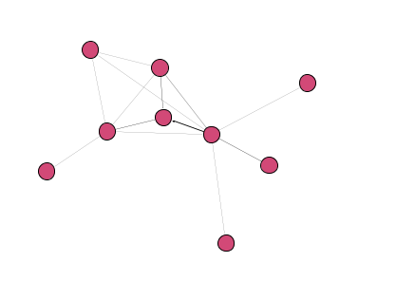 | This sub-network comprises 0.33% of the entire network. It has 4 nodes (1 technical and 3 social), and 3 edges. The central nodes is @edt400. A sub-network of 3 students gathered around a Course_ID – undergraduates from the University of Maine. Possibly brought here by their instructor, who is also taking the course and is a part of a different community. | 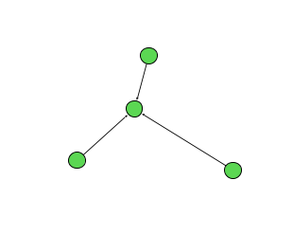
Sub-network comprises 0.057% of the entire network. It has 7 nodes (3 social and 4 technical), and 7 edges. The central nodes is @sayazyi. Can’t conclude the description for this sub-network. | 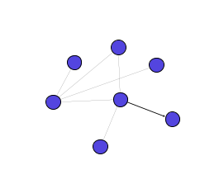 | This sub-network comprises 0.33% of the entire network. It has 4 nodes (3 social and 1 technical), and 5 edges. The central node is #p2p. Colours and size of the node are based on the in-degree.  An interaction between two people and an organization, which is a think tank for innovators, facilitated by their common interest: #p2p. The two people involved have interest in p2p and collective intelligence based on their stated interests and professional occupations. | 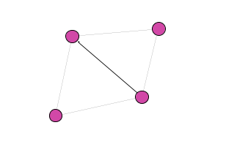

Can’t conclude anything about this sub-network due to the scarcity of data.
This sub-network comprises 0.24% of the entire network. It has 3 nodes (1 social and 2 technical), and 2 edges. The central node is #timgoldie.
It is an interaction of a British online community manager, based on his three hashtags.

This sub-network comprises 0.24% of the entire network. It has 3 nodes (3 social), and 2 edges.
An interaction between three Dutch people, one related to K12, two other unknown.

This sub-network comprises 0.24% of the entire network. It has 3 nodes (2 social and 1 technical), and 2 edges. It is a self-promotion sub-network, with entrepreneurial practitioners of education from the US, and his daughter organization, which is a forum for learning practitioners to gather and improve instructional design. | 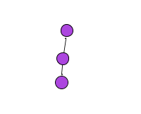
This sub-network comprises 0.16% of the entire network. It has 2 nodes (2 social), and 1 edge.  It is an interaction that occurred between two Canadian educational-related entrepreneurs from Edmonton, Canada, one of which just started his PhD in EdTech and joined the course. | 