Supplemental Information

Table of Contents

Appendix 1: Supplemental Figure 1
Appendix 2: Pre-test
Appendix 3: Demographic questions
Appendix 4: Survey questions
Appendix 5: Post-test

Appendix 1: Supplemental Figure 1
This is a place-holder. See the “figures” .pptx file.

Appendix 2: Pre-test

This pre-test was administered before the instructional phase of the study as a separate task. Only participants who answered three or more questions correctly were invited into the study.

------Pre-test text begins here-----

Question 1
Which of the following statements comparing bacteria and eukaryotes is true?
A Eukaryotic cells have a nucleus surrounded by a nuclear membrane; bacterial cells don’t.
B Eukaryotic cells don’t have cell walls; many bacterial cells do.
C The genetic material of eukaryotic cells is DNA; the genetic material of bacteria can be either DNA or RNA.
D Eukaryotic cells use a different code to specify amino acids in proteins than bacterial cells.

Answer: A

Question 2
A phospholipid molecule is shown in this diagram. The four diagrams A-D represent cross sections of spherical structures composed of phospholipids. Which of these structures is most likely to form when a phospholipid is vigorously dispersed in water?
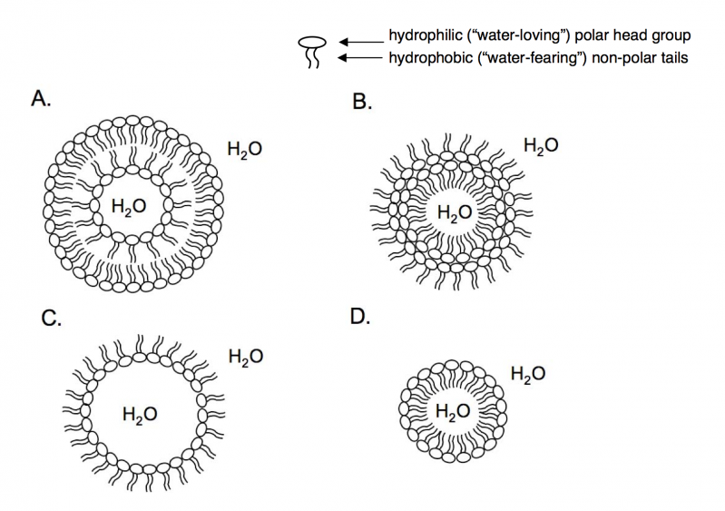
A Structure A
B Structure B
C Structure C
D Structure D

Answer: A

Question 3
Transcription is best represented by which of the following diagrams?
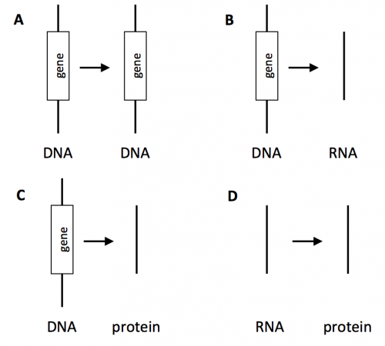
A
B
C
D

Answer: B

Question 4
Endocytosis is best described as a process of cells
A releasing substances through holes in the cell membrane.
B taking up substances through holes in the cell membrane.
C releasing substances in vesicles.
D taking up substances in vesicles.

Answer: D

Question 5
Which of the following does NOT describe an important cellular function of proteins?
A catalysts of biochemical reactions
B information storage molecules
C structural components of cells
D signaling molecules

Answer: B

Reference for questions 1, 2, and 3:
Shi, J., Wood, W. B., Martin, J. M., Guild, N. A., Vicens, Q., & Knight, J. K. (2010). A diagnostic assessment for introductory molecular and cell biology. CBE Life Sciences Education, 9(4), 453–461. http://doi.org/10.1187/cbe.10-04-0055

Appendix 3: Demographic Questions

This survey was administered at the beginning of the instructional phase of the study.

------Survey text begins here-----

What is your gender?
- Male
- Female

What is the highest level of education you have completed?
- Did not complete high school
- High school or equivalent
- Some college
- Associate degree
- Bachelor's degree
- Master's degree
- Doctoral or professional degree

How many hours per week do you spend on the following activities?
_____ Watching instructional videos
_____ Listening to instructional podcasts
_____ Reading instructional text online
_____ Taking online courses

Have you ever taken an online course, such as a massive open online course (MOOC)?
- Yes
- No

How familiar are you with each of the following topics?
 | Not at all | Slightly | Somewhat | Very | Extremely
Basic biology
Advanced biology (such as biochemistry, cell biology, or molecular biology)
Immunology

Appendix 4: Survey questions

This survey was administered at the end of the instructional phase of the study.

------Survey text begins here-----

Now please reflect on your experience taking this online lesson. Please answer each of these questions truthfully.

------New Survey Webpage-----

Please indicate your level of agreement with the following statements

 | Strongly Agree | Somewhat Agree | Neutral | Somewhat Disagree | Strongly Disagree
I would like to learn from more lessons like this
I enjoyed learning from this lesson
I understood the material in this lesson well
I found this lesson difficult
My mind wandered during the lesson
I found this lesson interesting
I exerted a large amount of effort in this lesson
I found this lesson confusing
------New Survey Webpage-----

In one week, you will have an opportunity to take a 10-point multiple choice quiz. All of the questions on the quiz were addressed in this instructional material. Please predict your score out of 10.

- 0 (lowest score)
- 1
- 2
- 3
- 4
- 5
- 6
- 7
- 8
- 9
- 10 (highest score)

------New Survey Webpage-----

Did you experience any technical problems taking this study?
- Yes
- No

Please describe the technical problems in detail here.

------New Survey Webpage-----

Was there anything confusing about this study to you?
- Yes
- No

Please describe confusing aspects of the study here.

Appendix 5: Post-test

This test was administered one week after the instructional phase of the study.

------Post-test text begins here-----

Question 1
Which of the cells below are tissue-resident sentinel cells? (select two answers)
A dendritic cells
B lymphocytes
C neutrophils
D monocytes
E mast cells

Answer: A,E

Question 2
A ____________ is a cell that uses innate immune receptors to recognize and phagocytose microbes; these cells have a short life span within tissue and often rapidly die by apoptosis.
A dendritic cell
B macrophage
C neutrophil
D monocyte
E mast cell

Answer: C

Question 3
A ____________ is a cell that uses innate immune receptors to recognize and phagocytose microbes. It also will phagocytose and digest apoptotic cells.

A macrophage
B lymphocyte
C monocyte
D mast cell

Answer: A

Question 4
Which of the cells below are circulating blood cells that will migrate into tissue in response to inflammation? (select two answers)
A red blood cells
B dendritic cells
C neutrophils
D monoctyes
E mast cells

Answer: C,D

Question 5
Pro-inflammatory cytokines and mediators bind to receptors on ____________ cells, which respond by undergoing changes that will promote the recruitment of circulating leukocytes from the blood into the tissue.
A endothelial cells
B red blood cells
C epithelial cells
D macrophages

Answer: A

Question 6
Leukocyte adhesion deficiency (LAD) is a genetic defect that leads to recurrent infections in the tissue and severe problems with wound healing. LAD patients also develop gingivitis (infections and inflammation of the gums). In LAD, leukocyte migration into tissues is severely impaired. All of these problems can be traced back to a genetic defect. Of the genetic defects listed below, which is the most likely cause of LAD?
A A mutation that impacts blood cell development, leading to below-normal numbers of monocytes, but normal numbers of other blood cells.
B A mutation that introduces a stop codon into a gene that encodes part of the LFA-1 molecule (leading to a truncated protein).
C A mutation that increases the stability of the E-selectin ligand protein without affecting its other functions.
D A mutation that leads to high pro-inflammatory cytokine expression in the tissue.

Answer: B

Question 7
Some of the steps of an acute inflammatory response are listed below. Which of these steps would occur first in a given episode of inflammation?
A Tissue-resident sentinel cells release inflammatory mediators.
B Microbial molecules bind to innate immune receptors.
C Endothelial adhesion molecule expression increases.
D Circulating neutrophils migrate into the tissue.

Answer: B

Question 8
Psoriasis is an inflammatory disease that impacts the skin. It most commonly manifests as scaly, raised, red or white areas on the skin caused by local inflammation. The inflammation leads to overgrowth of skin cells called keratinocytes. The triggers that lead to psoriasis are largely unknown, but microscopic examination of skin biopsies from psoriasis patients reveals massive infiltration of leukocytes into the tissue with no evidence of bacterial or viral infection.
Which drug or therapy would you expect to be LEAST effective in treating psoriasis?

A A treatment that blocks the release of pro-inflammatory cytokines.
B A treatment that blocks the removal of apoptotic neutrophils.
C A treatment that prevents the binding of LFA-1 to ICAM-1.
D A treatment that kills leukocytes that migrate into tissue.

Answer: B

